|  |
| --- |
| Experiment No. 3 |
| To realize half adder and full adder. |
| Name: Krithik Devendra Pandey |
| Roll Number: 35 |
| Date of Performance: |
| Date of Submission: |

**Aim -** To realize half adder and full adder.

**Objective -**

1. The objective of this experiment is to understand the function of Half-adder, Full-adder, Half-subtractor and Full-subtractor.
2. Understand how to implement Adder and Subtractor using logic gates.

**Components required** -

1. IC’s - 7486(X-OR), 7432(OR), 7408(AND), 7404 (NOT)

2. Bread Board

3. Connecting wires.

**Theory** -

Half adder is a combinational logic circuit with two inputs and two outputs. The half adder circuit is designed to add two single bit binary numbers A and B. It is the basic building block for addition of two single bit numbers. This circuit has two outputs CARRY and SUM.

Sum =A ⊕ B

Carry = A B

Full adder is a combinational logic circuit with three inputs and two outputs. Full adder is developed to overcome the drawback of HALF ADDER circuit. It can add two one bit umbers A and B. The full adder has three inputs A, B, and CARRY in,the circuit has two outputs CARRY out and SUM.

Sum = (A⊕B) ⊕ Cin

Carry = AB + Cin (A⊕B)  
 Subtracting a single-bit binary value B from another A (i.e. A -B) produces a difference bit D and a borrow out bit B-out. This operation is called half subtraction and the circuit to realize it is called a half subtractor. The Boolean functions describing the half- Subtractor are

Sum =A ⊕B

Carry = A’ B

Subtracting two single-bit binary values, B, Cin from a single-bit value A produces a difference bit D and a borrow out Br bit. This is called full subtraction. The Boolean functions describing the full-subtractor are

Difference = (A ⊕ B) ⊕Cin

Borrow = A’B + A’(Cin) + B(Cin)

**Circuit Diagram and Truth Table -**

**Half-adder**

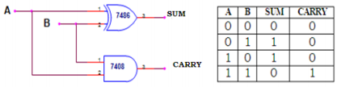

**Full-adder**

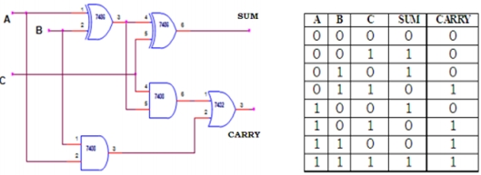

**Procedure -**

1. Verify the gates.

2. Make the connections as per the circuit diagram.

3. Switch on VCC and apply various combinations of input according to truth table.

4. Note down the output readings for half/full adder and half/full subtractor, Sum/difference and the carry/borrow bit for different combinations of inputs verify their truth tables.

**Output:-**

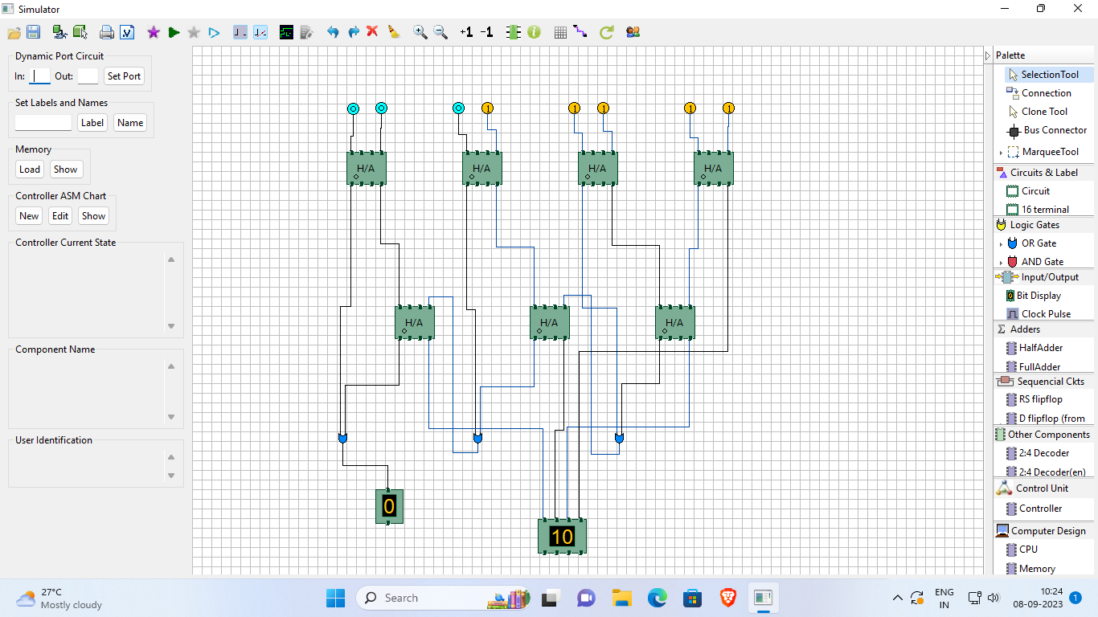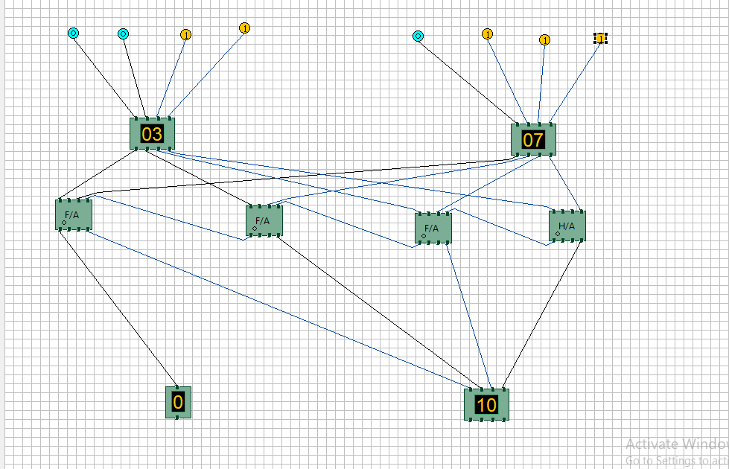

**Conclusion -**

The experiment conducted on the half adder and full adder using Logisim has provided valuable insights into the fundamental principles of digital logic design. We successfully demonstrated the basic operations of addition using half adders and extended our understanding to full adders, which can handle carry inputs. This hands-on experience not only reinforced our knowledge of binary arithmetic but also underscored the importance of these components in building more complex digital circuits.